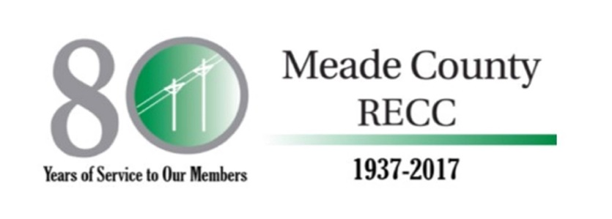
P.O. Box 489
Brandenburg, KY 40108-0489
270-422-2162
Fax: 270-4224705

Meade County RECC Solar Education Project

Over the past few years, we have seen an increase of inquiries about Solar Power from our member/owners. We have seen studies, analysis and statistics about solar projects and we determined it was a good time for us to explore this technology. Meade County RECC, along with its wholesale power supplier, Big Rivers Electric Cooperative, is building a small solar pilot project at both our Hardinsburg and Brandenburg offices.
The combined electricity produced by the two solar projects, will be about 42,000 kilowatt hours per year, enough power to supply all the energy needs of three homes on average. Keep in mind, solar power only produces electricity when the sun is out. Therefore, in the summer time, it produces more energy and during the winter, the days are shorter resulting in less electricity produced.
In addition to electricity, these solar power generators will produce information on the costs, dependability and availability of the power produced. Meade County RECC will measure the production based on the weather at each site and display that information at mcrecc.com as well as in the lobby of each location.
Ultimately the goal is to provide access to students and member/owners who are interested in learning how sunlight can be turned into electricity and comparing the costs to other traditional sources of electric generation.

Meade County Rural Electric Cooperative Corporation (Meade County RECC) is an electric distribution cooperative headquartered in Brandenburg, Kentucky. Meade County RECC is a not-for-profit electric cooperative that is owned by more than 29,000 member-consumers in Breckinridge, Meade, Ohio, Grayson, Hardin and Hancock counties.

